**A FACIAL EXPRESSION RECOGNITION SYSTEM**

**A PROJECT REPORT**

***Submitted by***

**Dibyajyoti Gouda** (21BAI10259)

**Sumaya Prakash Mohapatra** (21BAI10256)

**Goutam Sidhanth** (21BAI10417)

**Purva Samar** (21BAI10356)

**Jigyasa Shukla** (21BAI10160)

*in partial fulfillment for the award of the degree*

*of*

**BACHELOR OF TECHNOLOGY**

*in*

**COMPUTER SCIENCE AND ENGINEERING**



**SCHOOL OF COMPUTING SCIENCE AND ENGINEERING**

**VIT BHOPAL UNIVERSITY**

**KOTHRIKALAN, SEHORE**

**MADHYA PRADESH - 466114**

FEB 2023

0

**VIT BHOPAL UNIVERSITY, KOTHRIKALAN, SEHORE**

**MADHYA PRADESH – 466114**

**BONAFIDE CERTIFICATE**

Certified that this project report titled “**FACIAL EXPRESSION RECOGNITION SYSTEM**” is the bonafide work of “**Dibyajyoti Gouda (21BAI10259) Sumaya Prakash Mohapatra (21BAI10256) Gautam Sidhanth (21BAI10417) Purva Samar (****21BAI10356) Jigyasa Shukla (21BAI10160**)” who carried out the project work under my supervision. Certified further that to the best of my knowledge the work reported at this time does not form part of any other project/research work based on which a degree or award was conferred on an earlier occasion on this or any other candidate.

**PROGRAM CHAIR PROJECT GUIDE**

Dr. Suthir Sriram, Program chair- Division AIML Dr. Anil Kumar Yadav, Assistant professor

School of Computer Science and Engineering School of Computer Science and Engineering

VIT BHOPAL UNIVERSITY VIT BHOPAL UNIVERSITY

The Project Exhibition I Examination is held on 13th February, 2023

**ACKNOWLEDGEMENT**

First and foremost, I would like to thank the Lord Almighty for His presence and immense blessings throughout the project work.

I wish to express my heartfelt gratitude to **Dr. Suthir S**, Head of the Department, School of Computer Science and Engineering for much of his valuable support encouragement in carrying out this work.

I would like to thank my internal guide **Dr. Anil Kumar Yadav**, for continually guiding and actively participating in my project, giving valuable suggestions to complete the project work.

I would like to thank all the technical and teaching staff of the School of Computer Science and Engineering, who extended directly or indirectly all support.

Last, but not least, I am deeply indebted to my parents who have been the greatest support while I worked day and night for the project to make it a success.

### LIST OF FIGURES AND GRAPHS

|  |  |  |
| --- | --- | --- |
| **FIGURE NO.** | **TITLE** | **PAGE NO.** |
| 1 | FLOWCHART TO REPRESENT OVERALL PROCESS OF THE CODE | 16 |
| 2 | THE SYSTEM FLOW DIGRAM | 17 |
| 3 | ANALYSIS GRAPH | 22 |

**ABSTRACT**

The facial expression of human emotion is one of the major topics in facial recognition, and it can generate both technical and everyday application beyond laboratory experiment. Face Recognition is a computer application that is capable of detecting, tracking, identifying, or verifying human faces from an image or video captured using a digital camera. Although lot of progress has been made in domain of face detection and recognition for security, identification, and attendance purpose, but still there are issues hindering the progress to reach or surpass human level accuracy. It does this by analyzing faces in images or video through computer powered cameras embedded in laptops, mobile phones, and digital signage systems, or cameras that are mounted onto computer screens. This projection constructs a system of deep learning model to classify a given image of human facial emotion into one of the seven basic human emotions. The approach we take to build the model is through transfer learning of an existing pre-trained model, and the testing result will be evaluated based on accuracy of the mode. The accomplishments in the related areas such as psychological studies, human movement analysis, face detection, face tracking, and recognition make the automatic facial expression analysis possible. Automatic facial expression analysis can be applied in many areas such as emotion and paralinguistic communication, clinical psychology, psychiatry, neurology, pain assessment, lie detection, intelligent environments, and multimodal human computer interface

**TABLE OF CONTENTS**

|  |  |  |
| --- | --- | --- |
| **CHAPTER NO.** | **TITLE** | **PAGE NO.** |
|  | List of Figures and Graphs  Abstract | 3  4 |
| 1 | **CHAPTER-1:** |  |
|  | **PROJECT DESCRIPTION AND OUTLINE** | 8 |
|  | 1.1 Introduction |  |
|  | 1.2 Motivation for the work |  |
|  | 1.3 Problem Statement  1.4 Objectives |  |
| 2 | **CHAPTER-2: RELATED WORK INVESTIGATION**   * 1. Introduction   2. Core area of the project   3. Existing Approaches/Methods   4. Pros and cons of the stated approaches/Methods   5. Summary | 11 |

|  |  |  |
| --- | --- | --- |
| 3 | **CHAPTER-3: REQUIREMENT ARTIFACTS**   * 1. Introduction   2. Hardware and Software requirements | 14 |
| 4 | **CHAPTER-4:**  **DESIGN METHODOLOGY AND ITS NOVELTY**   * 1. Methodology and Goal   2. Software Architectural designs   3. Subsystem Service   4. Analysis | 17 |
| 5 | **CHAPTER-5:**  **TECHNICAL IMPLEMENTATION & ANALYSIS**   * 1. Outline   2. Technical coding and code solutions   3. Performance Analysis (Graphs/Charts) | 19 |

|  |  |  |
| --- | --- | --- |
| 6 | **CHAPTER-6:**  **PROJECT OUTCOME AND APPLICABILITY**   * 1. Outline   2. key implementations outline of the System   3. Significant project outcomes   4. Project applicability on Real-world applications | 24 |
| 7 | **CHAPTER-7: CONCLUSIONS AND RECOMMENDATION**   * 1. Outline   2. Limitation/Constraints of the System   3. Future Enhancements   4. Conclusion | 25 |
|  | **References** |  |

# CHAPTER-1

#### PROJECT DESCRIPTION AND OUTLINE

* 1. **Introduction**

Facial Emotion Recognition (FER) is the technology that analyses facial expressions from both static images and videos in order to reveal information on one’s emotional state. It is the visible manifestation of the affective state, cognitive activity, intention, personality, and psychopathology of a person and plays a communicative role in interpersonal relations. It has been studied for a long period of time and obtained progress in recent decades. Though much progress has been made, recognizing facial expressions with a high accuracy remains to be difficult due to the complexity and variety of facial expressions. Generally, human beings can convey intentions and emotions through nonverbal ways such as gestures, facial expressions, and involuntary language. This system can be a significantly useful, nonverbal way for people to communicate with each other. The important thing is how fluently the system detects or extracts the facial expression from the image. The system is growing attention because this could be widely used in many fields like lie detection, medical assessment, and human-computer interface. For decades, decoding such emotion expressions has been a research interest in the field of psychology (Ekman and Friesen 2003; Lang et al. 1993) but also to the Human Computer Interaction field (Cowie et al. 2001; Abd at et al. 2011). Recently, the high diffusion of cameras and the technological advances in biometrics analysis, machine learning and pattern recognition have played a prominent role in the development of the FER technology. The Facial Action Coding System (FACS), which was proposed in 1978 by Ekman and refined in 2002, is a very popular facial expression analysis tool. On a day-to-day basis, humans commonly recognize emotions by characteristic features, displayed as a part of a facial expression. For instance, happiness is undeniably associated with a smile or an upward movement of the corners of the lips. Similarly, other emotions are characterized by other deformations typical of a particular expression. Research into automatic recognition of facial expressions addresses the problems surrounding their presentation and categorization of static or dynamic characteristics of these deformations of face pigmentation The system classifies the facial expression of the same person into the basic emotions namely anger, disgust, fear, happiness, sadness, and surprise. The main purpose of this system is efficient interaction

between human beings and machines using eye gaze, facial expressions, cognitive modeling, etc. Here, the detection and classification of facial expressions can be used as a natural way for the interaction between man and machine. And the system intensity varies from person to person and also varies along with age, gender, size, and shape of the face, and further, even the expressions of the same person do not remain constant with time. However, the inherent variability of facial images caused by different factors like variations in illumination, pose, alignment, and occlusions makes expression recognition a challenging task. Some surveys on facial feature representations for face recognition and expression analysis addressed these challenges and possible solutions in detail.

#### Motivation

In today’s networked world the need to maintain the security of information or physical property is becoming both increasingly important and increasingly difficult. In countries like Nepal, the rate of crimes is increasing day by day. No automatic systems are there that can track a person's activity. If we will be able to track the Facial expressions of persons automatically then we can find the criminal easily since facial expressions change while doing different activities. So, we decided to make a Facial Expression Recognition System. We are interested in this project after we went through a few papers in this area. The papers were published on their system creation and way of creating the system for an accurate and reliable facial expression recognition system. As a result, we are highly motivated to develop a system that recognizes facial expressions and tracks one person’s activity.

#### Problem Statement

Human emotions and intentions are expressed through facial expressions and deriving an efficient and effective feature is the fundamental component of the facial expression system. Face recognition is important for the interpretation of facial expressions in applications such as intelligent, man-machine interface and communication, intelligent visual surveillance, teleconference, and real-time animation from live motion images. Facial expressions are useful for efficient interaction Most research and systems in facial expression recognition are limited to six basic expressions (joy, sadness, anger, disgust, fear, and surprise). It is found that it is insufficient to describe all facial expressions and these expressions are categorized based on facial actions. Detecting the face and recognizing facial expressions is a very complicated task when it is vital to pay attention to primary components like face configuration, orientation, and location where the face is set.

#### Objectives

To develop a facial expression recognition system.

To experiment with machine learning algorithms in computer vision fields.

To detect emotion thus facilitating Intelligent Human-Computer Interactions.

# CHAPTER 2

#### RELATED WORK INVESTIGATION

* 1. **Introduction**

A static approach using extracted features and emotion recognition using machine learning is used in this work. The focus is on extracting features using python and image processing libraries and using machine learning algorithms for prediction. Our implementation is divided into three parts. The first part is image pre-processing and face detection. For face detection, inbuilt methods available in dlib library are used. Once the face is detected, the region of interest and important facial features are extracted from it. There are various features that can be used for emotion detection. In this work, the focus is on facial points around the eyes, mouth, eyebrows, etc.

#### Core area of the project

In this system, the live image is captured from the live video is compared with the trained dataset available in the database and then the emotional state of the image will be displayed.

* 1. **Existing Approaches/Methods**

#### Setting up the database

Also, not all the images depict emotion; only some files have one of the emotions depicted from 1-7. All the files were of type portable networks graphic file(.png). The emotion labels are in a different directory but with the same name as the image files.

#### Face detection

Face detection was the first and most important part of the processing pipeline. Before further processing, we had to detect the face, even though our images contained only frontal facial expression data. We use the Haar-cascade algorithm to detect the face. Once the face was detected, it was easier to determine the region of interest and extract features from it.

#### Facial feature extraction

For facial feature extraction, we used the 68 landmark facial feature predictors from dlib. The Haar Cascade face detector algorithm returns a window (x,y, width, height) which is the detected face. The detected face is passed to the feature predictor algorithm.

#### Python pipeline

The dataset of 35887 files was stored in a directory and each file was processed to create the feature set. As soon as the file was picked up, the name of the file was parsed to extract the emotion label. The emotion label was appended to a list of labels that will form our multi-class target variable. The image was processed for face detection and feature prediction.

#### Machine learning

Once we had created the feature set and the target variable, we used CNN Model to predict the emotions. We build all the required layer in the model and used sequential API to bind all the layers. Then we use Sklearn machine library and Keras to apply the optimizers to speed up the training process and used. Then we stored the output in a file which can be used in Open CV to detect the emotion.

#### Pros and cons of the stated Approaches/Methods

Emotions that are not so common such as disgust, boredom, interest, etc. have fewer training images in our dataset as compared to emotions such as happy, sad, angry, surprised, shocked, etc. due to which the probability of recognizing these complex emotions accurately becomes much less.

The second limitation is that if multiple faces come in front of the glasses, or the person hides a part of his face with his hands it will not be able to read facial expressions and analyze emotions.

#### Summary

Our implementation can roughly be divided into 3 parts: 1) Face detection 2) Feature extraction 3) Classification using machine learning algorithms Feature extraction was a very important part of the experiment. The added distance and area features provided good accuracy for the database (89%). But for the cross-database experiment, we observed that raw features worked best with Logistic Regression for testing database and Mobile images dataset. The accuracy was 66% and 36% for both using the dataset as a training set.

# CHAPTER-3

#### REQUIREMENT ARTIFACTS

* 1. **Introduction**

In the planning phase study of reliable and effective algorithms is done. On the other hand, data were collected and preprocessed for more fine and accurate results. Since huge amounts of data were needed for better accuracy, we collected the data by surfing the internet. Since we are new to this project, we have decided to use a local binary pattern algorithm for feature extraction and support vector machines for training the dataset. We have decided to implement these algorithms by using the OpenCV framework.

#### Hardware and Software Requirements

Following are the software mainly used in our project:

* OpenCV
* Python
* TensorFlow
* Scikit-learn
* CNN
* Kaggle
* Haar-Cascade Face detector

Following are the hardware requirement necessary for the project:

* 2 Gb Storage
* Camera
* 8 Gb RAM
* Fluently working laptop

#### OpenCV:

OpenCV (Open-Source Computer Vision Library) is ahuge open-source computer vision and machine learning software library. which is built to provide a common infrastructure for machine learning algorithms and computer vision. It has thousands of optimized algorithms which can be used different purposes like detecting and recognizing faces, identifying objects and many more. We need it to take pictures using our webcam and some manipulation needed to be done in the image. Python

Importing the required python libraries like NumPy, seaborn, matplotlib, TensorFlow, pandas, random, Keras, scikitplot, os, and warnings. Now we will get the dataset on which our model will be trained and we will validate how good or bad our model has performed on that particular dataset so that we can improve the accuracy score. We have used 30 epochs to train the model with epochs to limit 48 per epochs.

#### CNN:

Deep Learning – which has emerged as an effective tool for analyzing big data

– uses complex algorithms and artificial neural networks to train machines/computers so that they can learn from experience, and classify and recognize data/images just like a human brain does. Within Deep Learning, a Convolutional Neural Network or CNN is a type of artificial neural network, which is widely used for image/object recognition and classification.

#### Kaggle:

Kaggle is an online community platform for data scientists and machine learning enthusiasts. Kaggle allows users to collaborate with other users, find and publish datasets, use GPU-integrated notebooks, and compete with other data scientists to solve data science challenges. We have taken FER 2013 dataset from Kaggle.

**CHAPTER 4**

**DESIGN METHODOLOGY AND ITS NOVELTY**

#### 4.1 METHODOLOGY AND GOAL

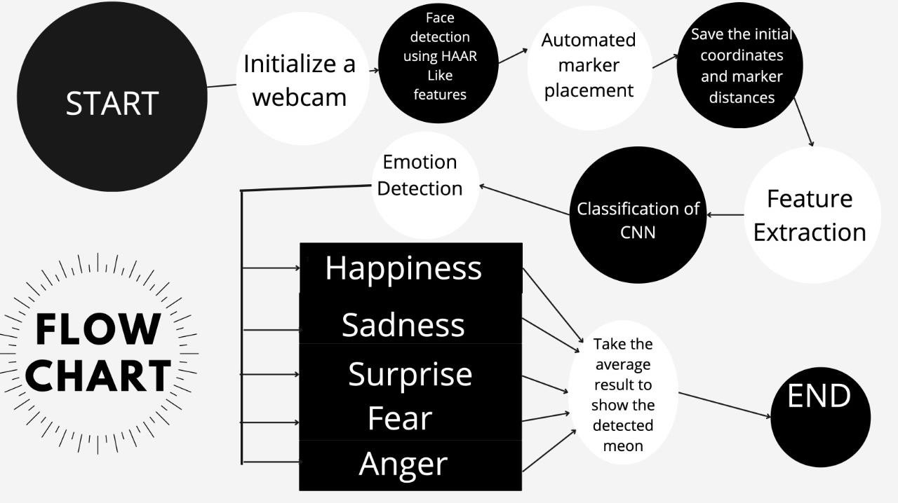

FLOWCHART TO REPRESENT OVERALL PROCESS OF THE CODE

#### KNOWLEDGE BASE

This base contains images that are used for comparison and recognizing emotion variations. The images are stored in the database. Every time an input is given to the system, it finds a relevant image from its knowledge base by comparing the stored pictures and the input to come up with an output.

#### PREPROCESSING AND RESIZE

This step enhances the input and removes different types of noises. After that, the input image will be resized, we select a common size of 48 for all photos, typically with the use of the eye selection method.

#### DIFFERENCE MEASUREMENTS

During this step, the system will find any differences between the input image and the stored images and will finally lead to the emotion recognition step.

#### EMOTION RECOGNITION

This is the final step of the process. The comparison is made, and the final output is given on the live screen depending on the differences found.

#### 4.2 Software Architectural designs:

* An end-to-end deep learning framework, based on attentional convolutional network.
* Attention mechanism is added through spatial transformer network

FIG.4. 2 THE SYSTEM FLOW DIGRAM

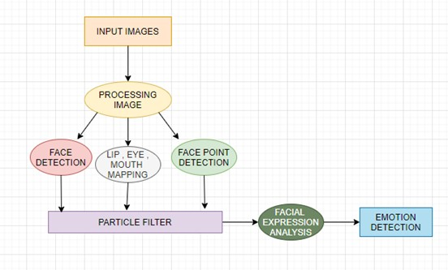

In this Fig.4.2 we have taken the dataset then data is processed using CNN architecture for model training and the result will be displayed on the screen

#### 4.3 Subsystem services:

With a CNN, an input image is filtered through convolution layers to produce a feature map. This map is then input to fully connected layers, and the facial expression is recognized as belonging to a class based on the output of the FE classifier.

#### 4.4 Analysis

Accuracy prediction is important in any machine learning model process because it ensures that the model created works properly and can be used with trust. A matplotlib graph is used to display the graphical plotting of increase in the accuracy and decrease in the loss in a graph format.

## CHAPTER 5

**TECHNICAL IMPLEMENTATION & ANALYSIS**

#### 5.1 OUTLINE

#### Data Collection: Collect a dataset of images of faces with varying angles, lighting conditions, and backgrounds.

#### Preprocessing: Preprocess the images to normalize their sizes, brightness, and contrast.

#### Haar Cascade Classifier: Use Haar Cascade classifiers to detect the presence of faces in the images. This involves using a set of pre-trained classifiers to identify facial features such as the eyes, nose, and mouth.

#### CNN Algorithm: Train a CNN algorithm on the detected faces to classify them into different categories. This involves feeding the detected faces as input to the CNN and fine-tuning the weights of the network to optimize the classification accuracy.

#### Integration with OpenCV: Integrate the trained CNN algorithm and Haar Cascade classifiers with OpenCV to create a real-time facial detection system.

#### Testing and Evaluation: Test the system on new images and evaluate its accuracy and speed.

#### 5.2 TECHNICAL CODING AND CODE SOLUTION

Importing all the modules

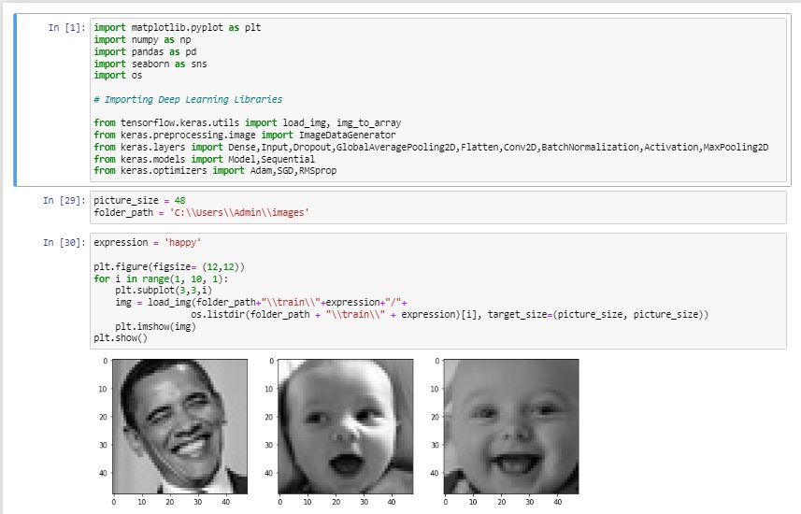

Making Training and validation data

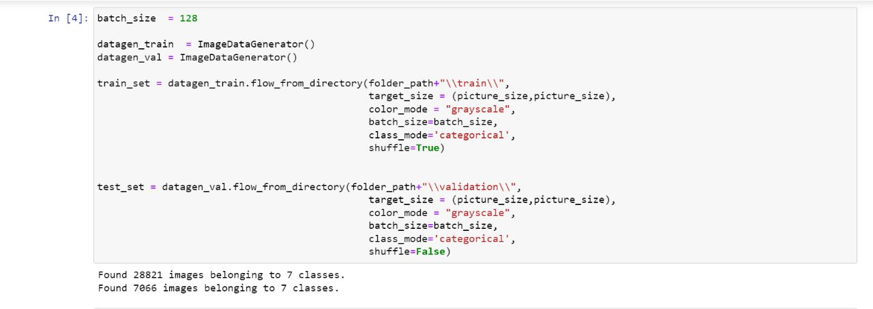

Model Building

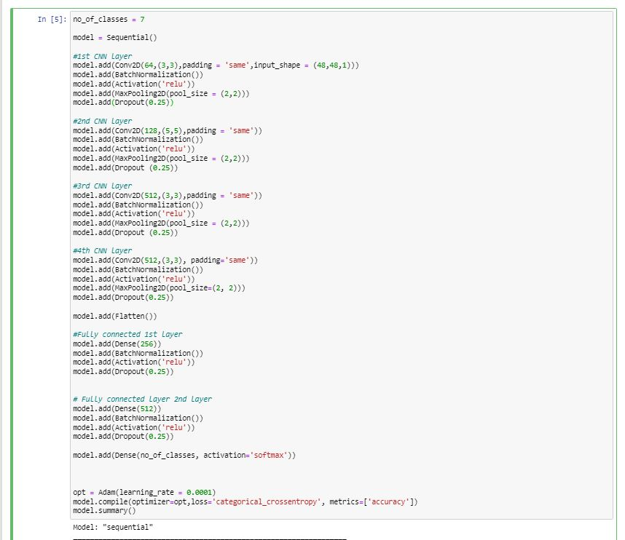

Fitting the Model with Training and Validation data

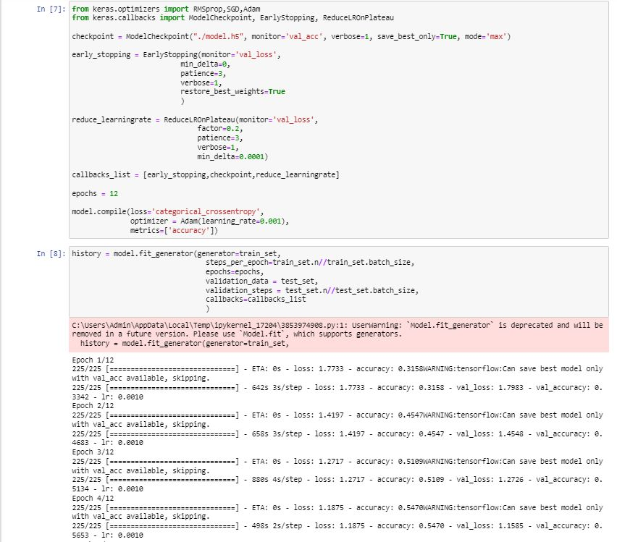

Open CV Implementation

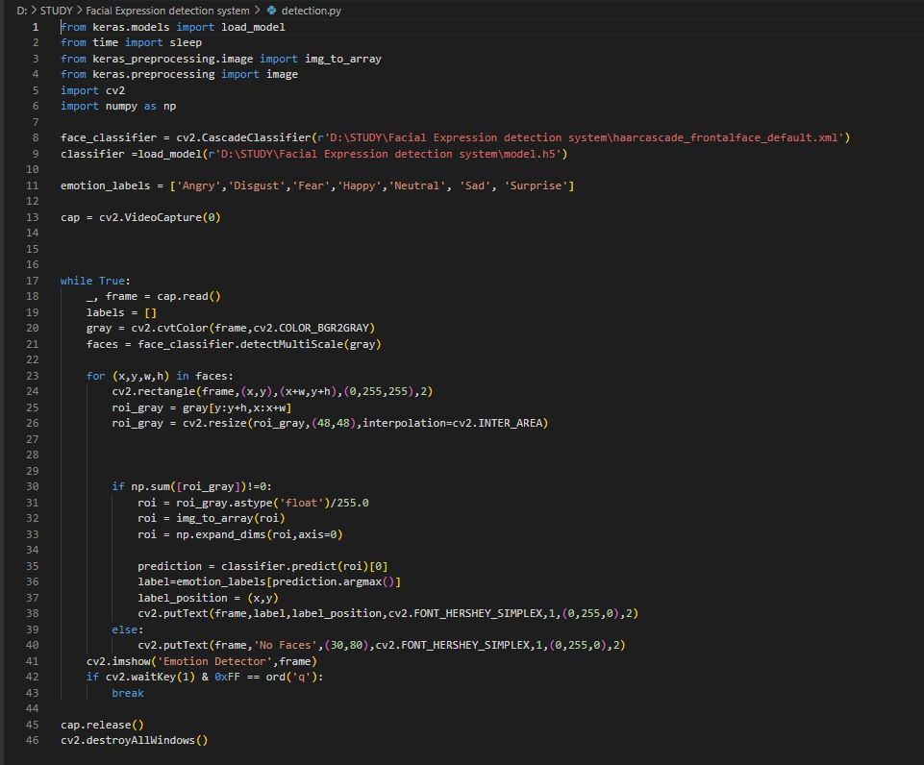

#### 5.3 Performance Analysis (Graphs/Charts):

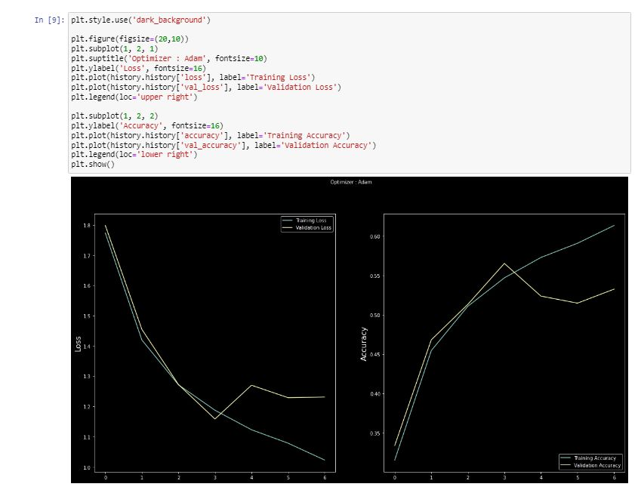

# CHAPTER-6

#### PROJECT OUTCOME AND APPLICABILITY

* 1. **Outline**

The analysis of human sentiments, which is also referred to as mining of opinions or Emotion AI in circumstances, uses face detection algorithms and predictions of emotions through the facial expression of individual acts as an asset to various fields and can be used in various research works.

#### Key implementations outline the System

People in their daily life experience varying emotional states, some of which are negative and which can lead to decreased attention, decreased productivity, and ultimately, reduced quality of life. The implementation of our project is to continuously monitor the physiological signals of the person and assess his or her emotional well- being by using facial expressions and acting as an aid to various domains of research and in solving real-life problems.

#### Significant project outcomes

Human emotion detection can be implemented in many areas requiring additional security or information about the person. It can be used as a second step to face detection where we may be required to set up a second layer of security, where the emotion is also detected along with the face. This can be useful to ensure that the person standing in front of the camera is not just a 2-dimensional representation.

#### Project applicability to Real-world applications

Facial expression recognition (FER) is an interesting and challenging area for the computer vision field and it can be applied to various areas like mental state identification, tracking and surveillance, automatic counseling systems, face expression synthesis, check-in check out process for patients, lie detection, music for mood, automated tutoring systems, operator fatigue detection, etc.

# CHAPTER 7

#### CONCLUSIONS AND RECOMMENDATION

* 1. **Outline**

So, till now, we have seen what is the project all about our investigation of the project approaches hardware software requirements implementations, etc. now we will be looking at some of the limitations of our project and future enhancements.

#### Limitations/ constraints of the system

**Poor Image Quality Limits Facial Recognition's Effectiveness**

Image quality affects how well facial-recognition algorithms work. The image quality of scanning video is quite low compared with that of a digital camera. Even high-definition video is, at best, 1080p (progressive scan); usually, it is 720p. These values are equivalent to about 2MP and 0.9MP, respectively, while an inexpensive digital camera attains 15MP. The difference is quite noticeable.

#### Small Image Sizes Make Facial Recognition More Difficult

When a face-detection algorithm finds a face in an image or in a still from a video capture, the relative size of that face compared with the enrolled image size affects how well the face will be recognized. An already small image size, coupled with a target distant from the camera, means that the detected face is only 100 to 200 pixels on a side. Further, having to scan an image for varying face sizes is a processor-intensive activity. Most algorithms allow specification of a face-size range to help eliminate false positives on detection and speed up image processing.

#### Different Face Angles Can Throw Off Facial Recognition's Reliability

The relative angle of the target’s face influences the recognition score profoundly. When a face is enrolled in the recognition software, usually multiple angles are used (profile, frontal and 45-degree are common). Anything less than a frontal view affects the algorithm’s capability to generate a template for the face. The more direct the image (both enrolled and probe image) and the higher its resolution, the higher the score of any resulting matches.

#### Data Processing and Storage Can Limit Facial Recognition Tech

Even though the high-definition video is quite low in resolution when compared with digital camera images, it still occupies significant amounts of disk space. Processing every frame of video is an enormous undertaking, so usually, only a fraction (10 percent to 25 percent) is actually run through a recognition system. To minimize total processing time, agencies can use clusters of computers. However, adding computers involves considerable data transfer over a network, which can be bound by input-output restrictions, further limiting processing speed.

Ironically, humans are vastly superior to technology when it comes to facial recognition. But humans can only look for a few individuals at a time when watching a source video. A computer can compare many individuals against a database of thousands.

#### Future Enhancements

Facial emotion recognition is an emerging field so considering other NNs such as Recurrent Neural Networks (RNNs) may improve the accuracy A historical glance at headlines around automated FER over the last decade or so reveals a number of bold announcements by variously-sized tech companies for FER products which either fail to materialize or else disappear or are later downplayed by the originating company. The feature extraction is like pattern recognition which is used in intelligence, military, and forensics for identification purposes. Thus, techniques such as the Caps net algorithm for pattern recognition can be considered. DL-based approaches require a large labeled dataset, significant memory, and long training and testing times which makes them difficult to implement on mobile and other platforms with limited resources. Thus, simple solutions should be developed with lower data and memory requirements.

**CONCLUSION**

We know that emotions play a major role in Human life. At different kinds of moments or times, the Human face reflects how he/she feels or in which mood he/she is. Humans can produce thousands of facial actions during communication that varies in complexity, intensity, and meaning. Emotion or intention is often communicated by subtle changes in one or several discrete features paper discusses the application of feature extraction of facial expressions with the combination of neural networks for the recognition of different facial emotions (happy, sad, angry, fear, surprised, neutral, etc..). Humans can produce thousands of facial actions during communication that varies in complexity, intensity, and meaning. This report analyses the limitations of the existing system of Emotion recognition Purposed system depends upon the human face as we know the face also reflects the human brain activities or emotions. In this report, the neural network has been used for better results. At the end of the paper comparisons of the existing Human Emotion Recognition System have been made with new one.

## REFERENCES

**1.**M. Brackett, "Emotional intelligence", *Character Lab Playbook*, vol. 21, pp. 91, Aug. 2019.

**2.**M. Fahim, M. Idris, R. Ali, C. Nugent, B. Kang, E.-N. Huh, et al., "ATHENA: A personalized platform to promote an active lifestyle and wellbeing based on physical mental and social health primitives", *Sensors*, vol. 14, no. 5, pp. 9313-9329, May 2014.

1. C. D. Katsis, G. Ganiatsas and D. I. Fotiadis, "An integrated telemedicine platform for the assessment of affective physiological states", *Diagnostic Pathol.*, vol. 1, no. 1, pp. 16, Dec. 2006.
2. E. Reynolds, "Nevermind: Creating an entertaining biofeedback-enhanced game experience to train users in stress management", *Proc. ACM SIGGRAPH Posters (SIGGRAPH)*, pp. 1, 2013.
3. C.-H. Wu, Y.-M. Huang and J.-P. Hwang, "Review of affective computing in education/learning: Trends and challenges", *Brit. J. Educ. Technol.*, vol. 47, no. 6, pp. 1304-1323, Nov. 2016.
4. R. Mehmood and H. Lee, "Towards building a computer aided education system for special students using wearable sensor technologies", *Sensors*, vol. 17, no. 2, pp. 317, Feb. 2017.
5. K. Wac and C. Tsiourti, "Ambulatory assessment of affect: Survey of sensor systems for monitoring of autonomic nervous systems activation in emotion", *IEEE Trans. Affect. Computer.*, vol. 5, no. 3, pp. 251-272, Jul. 2014